**AIAC LAB TEST -2**

**NAME:Mirza Shahzeb Baig**

**Rollno:2403A51019**

**Batch:01**

Subgroup D  
D.1 — [S13D1] TDD: increment version suffix  
Scenario (agritech):  
Context:  
File versioning in the agritech data pipeline uses a `_vNN` suffix before the extension.  
Your Task:  
Create tests and implement bump_version(name) that adds or increments `_vNN` with zero-  
padding.  
Data & Edge Cases:  
Handle names with and without existing suffix; preserve original extension.  
AI Assistance Expectation:  
Use AI to propose regex and test cases for edge names like `report_v9.csv`, `summary.csv`.  
Constraints & Notes:  
Preserve original extension and base name.  
Sample Input  
['report_v1.csv', 'summary.csv', 'log_v09.txt']  
Sample Output  
['report_v02.csv', 'summary_v01.csv', 'log_v10.txt']

Acceptance Criteria: Correct zero-padding; extension preserved.

**Prompt:**

Generate a python code to implement bump_version(name) that adds or increments’_vNN’ with zero- padding. Data & Edge Cases:  
Handle names with and without existing suffix; preserve original extension.  
AI Assistance Expectation:  
Use AI to propose regex and test cases for edge names like `report_v9.csv`, `summary.csv`.  
Constraints & Notes:  
Preserve original extension and base name. and give me unit test cases.

OUTPUT: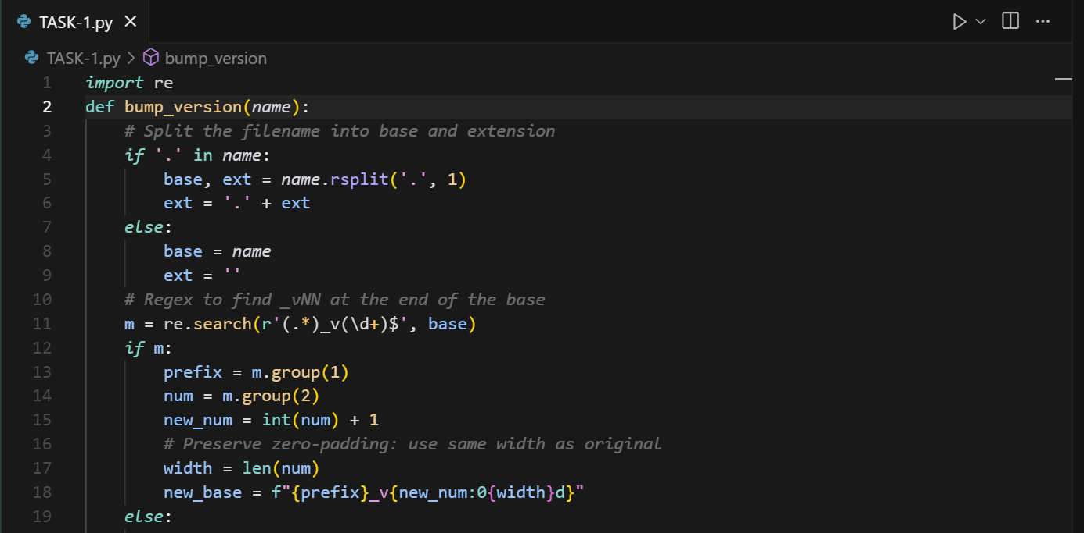

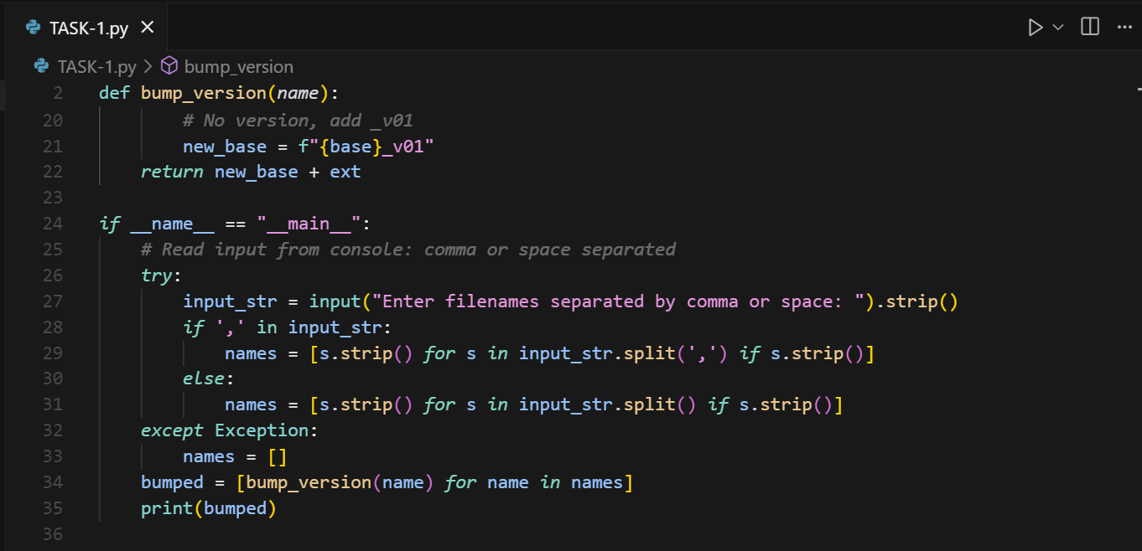

D.2 — [S13D2] Generate docstrings and usage examples  
Scenario (agritech):  
Context:  
Data analysts in agritech normalize metrics to [0,1] for comparability.  
Your Task:  
Add Google-style docstrings and handle the edge-case where all scores are equal (avoid divide-  
by-zero).  
Data & Edge Cases:  
Empty lists return empty; if max==min, return zeros of the same length.  
AI Assistance Expectation:  
Use AI to draft docstrings with Args/Returns/Examples and generate unit tests for edge-cases.  
Constraints & Notes:  
Add tests demonstrating the m==n case.  
Sample Input  
def normalize(scores):  
m = max(scores); n = min(scores)  
return [(x-n)/(m-n) for x in scores]  
Sample Output  
Docstring includes Args/Returns/Examples; guard for m==n.

Acceptance Criteria: Doc quality and guard confirmed by tests.

**PROMPT:**

Generate a python code to Add Google-style docstrings and handle the edge-case where all scores are equal (avoid divide-by-zero).  
Data & Edge Cases:  
Empty lists return empty; if max==min, return zeros of the same length.  
AI Assistance Expectation:  
Use AI to draft docstrings with Args/Returns/Examples and generate unit tests for edge-cases.  
Constraints & Notes:  
Add tests demonstrating the m==n cases.read the value from the console.

**OUTPUTS:**

